**Keyboard Hero User Manual**

Welcome to the user manual for the program Keyboard Hero, the program that lets you play a rhythm game with any song you want.

Starting the Game

In order to start the game once you have downloaded it, first open command prompt for windows machines or terminal for Linux and Macs. After opening it, you will want to change your directory to the location of the OfficialFortranFanclub_KeyboardHero file that was downloaded so you can start the game. You can change the directory in the command prompt with the command cd “Insert Folder Name You’re Moving to.” After changing your directory to the OfficialFortranFanclub_KeyboardHero, you will start the game by running the file called gameMenus.py (Image 1).

*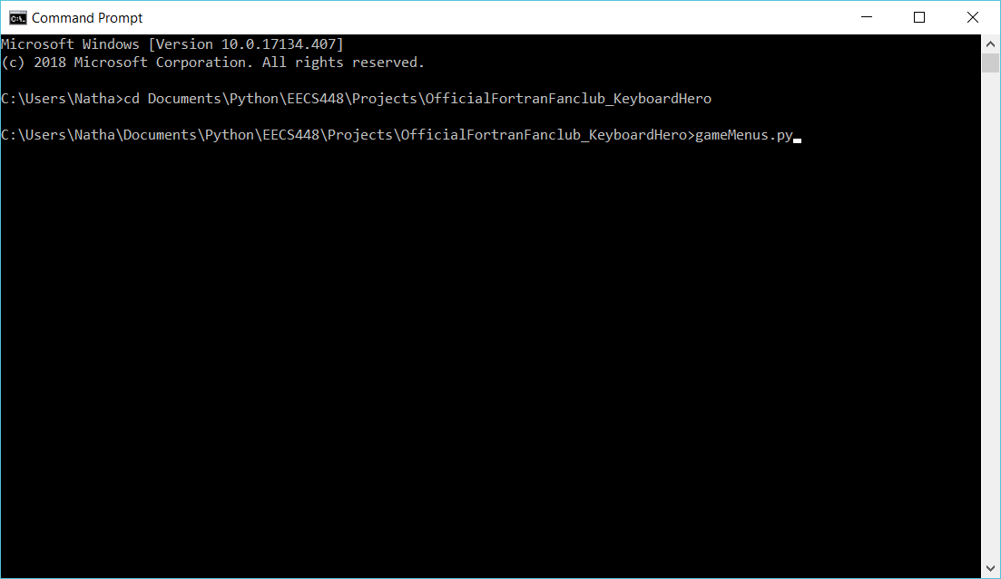Image 1*

Navigating the Menus

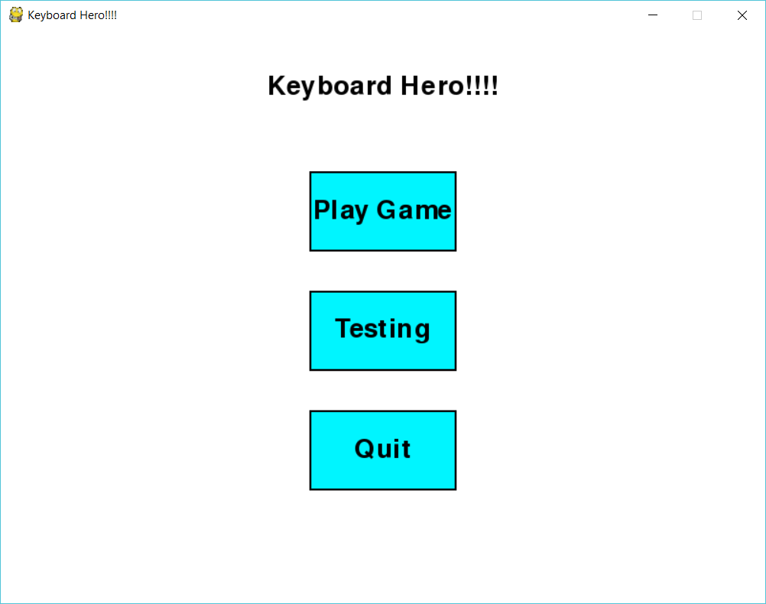When you open the game, it will bring you to the main menu (Image 2). In this menu, you have the option to either play the game, run a series of tests, or quit as shown below. Selecting Play Game will bring you to the Song Selection menu, while Testing will run a series of tests and save them to a text file named ___. Quit, as you can imagine, will exit the game.

*Image 2*

In the song selection menu, there will be two options to either Select a Song or go back (Image 3). The back button will return you to the previous menu, while the Select Song button will open a file browser. That file browser is where you will select your song that you will use, but it is important that the file is in the correct place and format. **The song that you wish to use must be a .wav music file that is located in the OfficialFortranFanclub_KeyboardHero folder.** If the song is any other type of file, it won’t show up in the file browser. And if the file isn’t inside the OfficialFortranFanclub_KeyboardHero folder, it won’t be accessed correctly and the song notes will fail to be generated.

*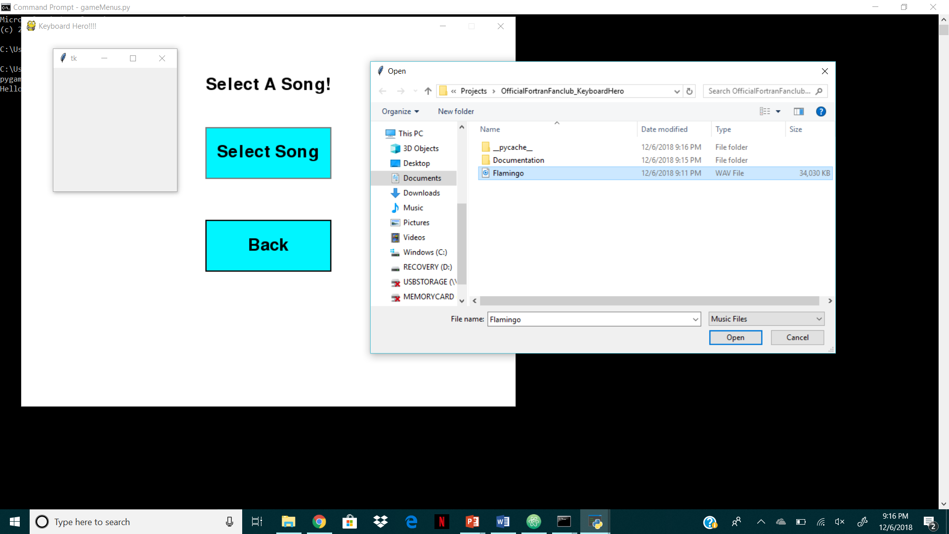Image 3*

Once the song is selected, it will automatically begin to generate a beatmap for it. This may take a few seconds depending on the length of the song. If you wish to confirm that the song you selected is the correct one, it will print the file name to your terminal. In the event that you accidently select the wrong song, you can press back in the Mode Selection menu that will pop up after the notes are generated and select a new one. The Mode Selection will have two other options besides going back, either an OSU mode or a Regular mode (Image 4). You can look in the gameplay section to learn more about the differences between these two modes Selecting one of these modes will bring you to the Difficulty Selection, where you can choose between Easy, Medium, and Hard (Image 5).

*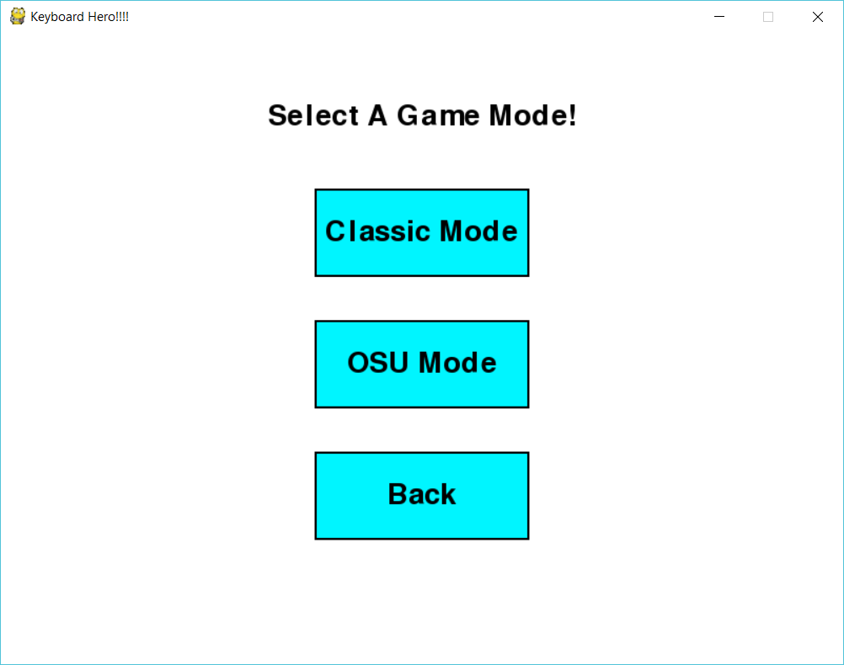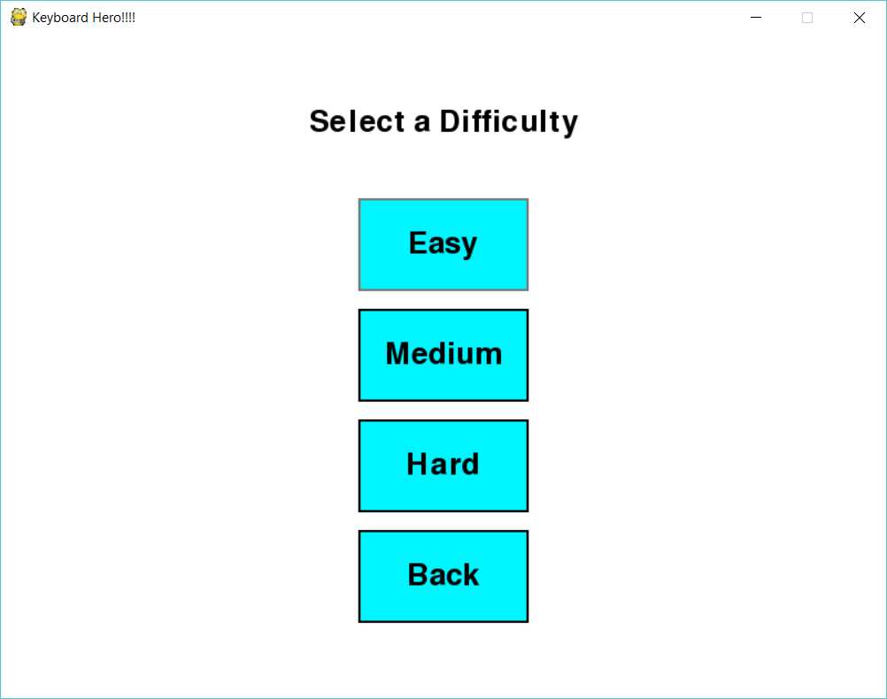Image 4*

*Image 5*

Gameplay

In Keyboard Hero!, there are two types of game modes to choose from. The first of these game modes is regular, which is a classic rhythm game. The game screen will be as shown, with the players score and combo displayed at the top and four columns labeled Left, Right, Up, or Down (Image 6).

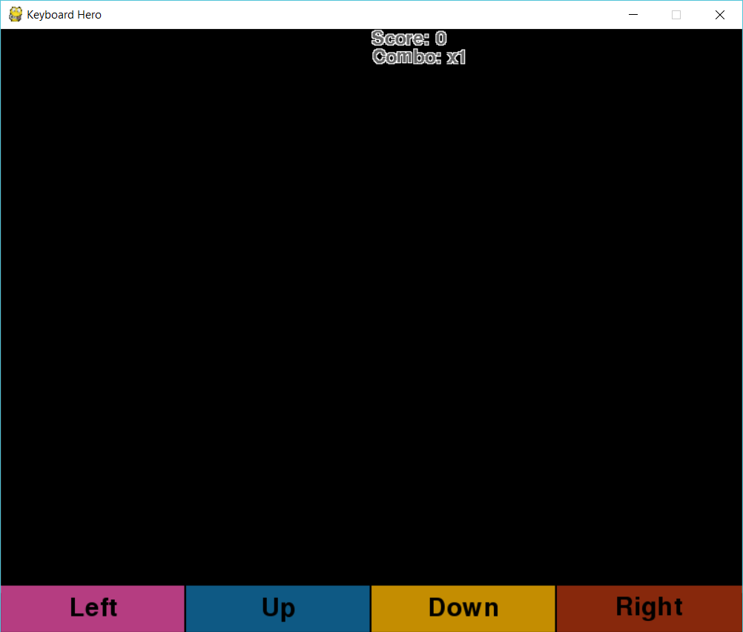 *Image 6*

As the song progresses, notes will begin to appear at the top of the screen and fall down at a specific speed based on the tempo of the song. These notes will be in one of the four columns, and the objective of the game is to press the cursor control keys, which are the up, down, left and right buttons on the computers keyboard, that corresponds to the column the note is in (Image 7). If the player presses the correct key when a note is on the buttons, they will earn points. And if they click it with a certain percentage of the note over the button, the players combo will increase, going up to 4. A higher combo means you get more points per a note, so its always a good thing to have. However, if you mistime a click, then the combo will disappear, so be careful with the timing! 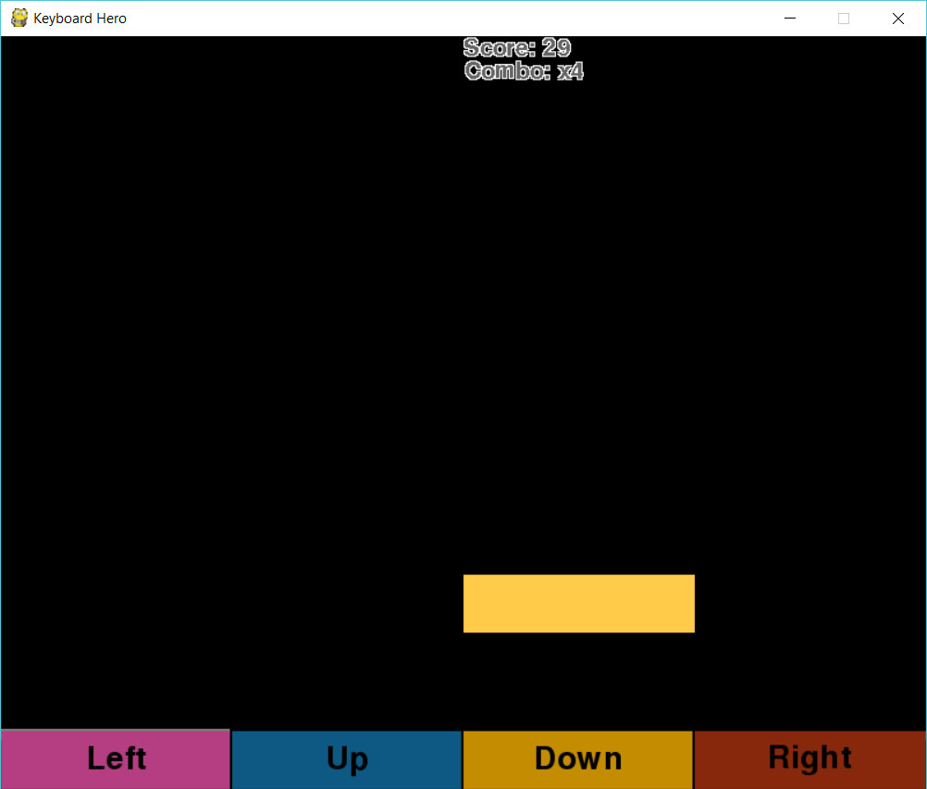

*Image 7*

The second game mode is OSU mode, which is a bit different. Instead of using you’re keypad for OSU mode, you actually use the mouse to click circles that are generated. The circles will have another circle that is shrinking, and to get the note you must click on the inner circle before the note vanishes (Image 8). The scoring and combos are still the same in this mode, but it requires faster reflexes for an extra challenge if you’re up for it!

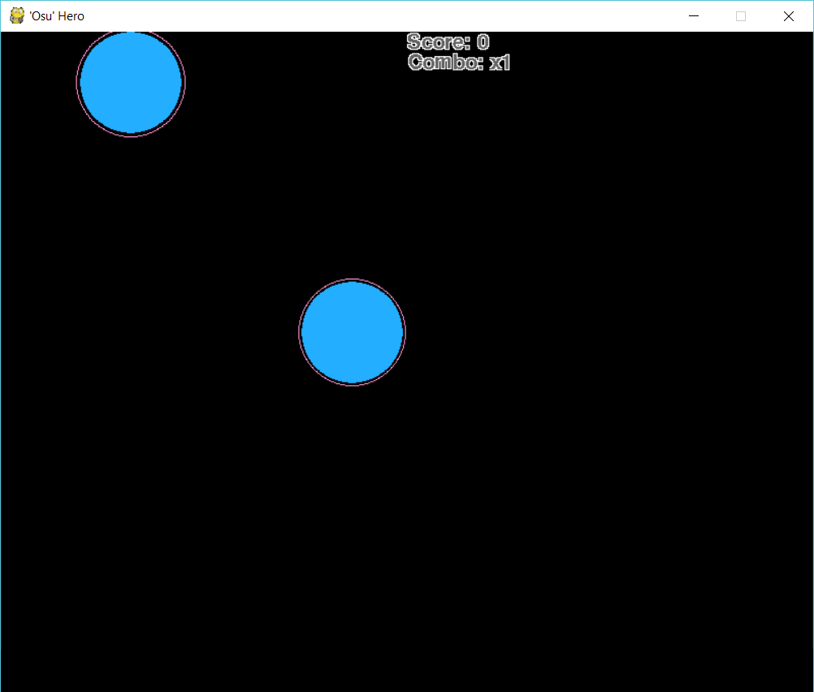

*Image 8*

Leaderboard

After you finish the game in either mode in any difficulty, you will be able to see if you are one of the best at it. Your score for that specific song, mode, and difficulty will be compared to the other top scorers, and if you managed to get in the top 10 you will be able to save your score and immortalize this moment of glory! This will be done in the terminal, where you’re score will be posted after you finish or quit. In the event you managed to get a high score, you will be asked to enter a name for the leaderboard. After you do, the top 10 players for that song, mode, and difficulty will be displayed along with their ranks. Keep playing until you manage to take the number one spot as the Keyboard Champ!

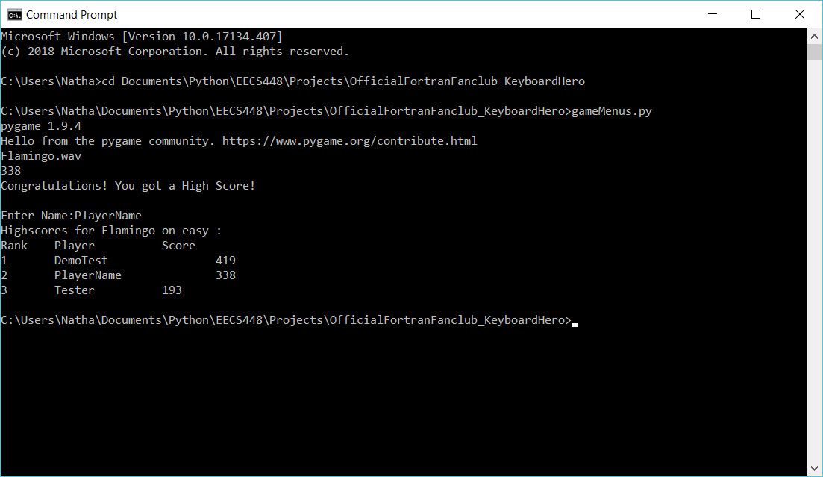*Image 9*